# CURRENCY CONVERTER

### A MINI PROJECT REPORT

#### Submitted by

#### Group/Team No: G-10/PG-26

**PALLAVI THAKUR: 2310990844**

**MADHAV KESHAV SINGLA: 2310991366**

**DHRUV SUNEJA: 2310991367**

#### in partial fulfillment for the award of the degree of

## BACHELEOR OF ENGINEERING

***in***

COMPUTER SCIENCE & ENGINEERING



**CHITKARA UNIVERSITY**

**CHANDIGARH-PATIALA NATIONAL HIGHWAY**

**RAJPURA (PATIALA) PUNJAB-140401 (INDIA)**

##### 6 DECEMBER 2023

**ABSTRACT**

This project is website-based project and this website help to currency convert according to rate of country currency. The Currency Converter website is helping to convert money like Indian Rupees to American Dollar or Indian Rupees to Dubai Dirham. Different countries use different currency, and there is daily variation in these currencies relative to one another. Those who transfer money from one country to another (one currency to another) must be updated with the latest currency exchange rates in the market. And this website mainly helpful in business, shares, and finance.

The user enters an amount of money in a specific currency and the application converts it into the equivalent amount in another currency.

This report presents an in-depth analysis of a currency converter application, designed to facilitate seamless currency exchange for global users. The currency converter offers real-time conversion rates and supports a wide range of currencies, catering to the diverse needs of international travellers, businesses, and investors.

Key features of the currency converter application, including user interface design, currency data sources, and conversion algorithms, are examined in detail. Performance metrics and usability evaluations highlight its efficiency and user-friendliness

In conclusion, this report provides a comprehensive assessment of the currency converter application, emphasizing its reliability, user experience, and adaptability to evolving market conditions. The findings serve as a valuable resource for developers, businesses, and users seeking to make informed decisions in the realm of currency exchange.

###### TABLE OF CONTENTS

|  |  |  |
| --- | --- | --- |
| 1 | Introduction | **3** |
| 2 | Problem statement | **4** |
| 3 | Technical Details | **5** |
| 4 | Key Features | **6** |
| 5 | Project Advantages | **7** |
| 6 | Results | **8-11** |
| 7 | Conclusion | **12** |
| 8 | References | **13** |

**INTRODUCTION**

In an increasingly interconnected world, the need for efficient and accurate currency conversion tools has become paramount. The global economy thrives on international trade, travel, and investment, all of which require seamless currency exchange. This report delves into the intricacies of currency conversion, focusing on the development and evaluation of a currency converter application designed to address these demands.

The currency converter is a fundamental tool for individuals, businesses, and financial institutions, allowing them to transact and operate across borders with ease. As currencies fluctuate in response to economic, political, and social factors, the ability to access real-time exchange rates is crucial for making informed decisions.

This report embarks on a journey to understand the inner workings of our currency converter, examining its underlying algorithms, data sources, and user interface. We will also explore the challenges associated with currency conversion, including data accuracy, security, and the impact of external factors on exchange rates.

Furthermore, we will assess the performance and user experience of our currency converter, ensuring that it meets the high standards expected by today's users. Additionally, we will scrutinize the regulatory landscape, emphasizing the importance of compliance with international financial regulations and data privacy laws.

Ultimately, this report aims to provide a comprehensive understanding of the currency converter application and its relevance in the ever-evolving global financial landscape. By the end of this journey, readers will gain valuable insights into the world of currency conversion, and developers will be equipped with the knowledge needed to create effective and reliable currency converter tools.

**PROBLEM STATEMENT**

In today's globalized world, where international transactions, travel, and investments have become commonplace, the efficient and accurate conversion of currencies is of paramount importance. However, despite the increasing reliance on currency conversion tools, there remain several pressing challenges that need to be addressed.

* **Currency Fluctuations**: Currency exchange rates are subject to constant fluctuations driven by economic, geopolitical, and market factors. These fluctuations can have a significant impact on the financial outcomes of individuals and businesses engaged in international activities.
* **Data Accuracy**: The reliability of currency conversion tools heavily relies on the accuracy and timeliness of the exchange rate data they use. Ensuring the precision of these rates is essential to prevent financial losses and discrepancies in transactions.
* **User Experience**: Users of currency conversion applications demand a seamless and intuitive experience. A poor user interface, slow response times, or complex navigation can hinder the effectiveness of these tools.
* **Adaptability to Market Changes**: To remain relevant and reliable, currency converters must adapt to changing market conditions, such as new currencies, emerging markets, and evolving financial technologies.

This report aims to address these challenges comprehensively by examining the development and evaluation of a currency converter application. Through an in-depth analysis, we seek to provide solutions and insights that can enhance the efficiency, accuracy and ultimately benefiting individuals, businesses, and financial institutions engaged in international activities.

**TECHNICAL DETAILS**

**Hardware Details:**

|  |  |
| --- | --- |
| Device Name | Dhruv |
| Processor | AMD Ryzen 7 6800H |
| Installed RAM | 8.00 GB |
| Device ID | C0588497-3BD2-46D4-91DE-671868B90C4B |
| Product ID | 00342-42595-27295-AAOEM |
| System Type | 64-bit operating system, x64-based processor |
| Pen and Touch | No pen or touch input is available |

**Software Details:**

Visual Studio Code version 1.83



**Language used:**

* **HTML**- HTML stands for Hyper Text Markup Language. HTML is the standard markup language

for creating Web pages. HTML describes the structure of a Web page.

* **CSS**- Cascading Style Sheets (CSS) is a style sheet language used for describing the presentation of

a document written in a markup language such as HTML

* **JavaScript**- JavaScript is a scripting or programming language that allows you to implement complex

features on web pages

**KEY FEATURES**

These key features collectively contribute to the project's commitment to accuracy, making

it a dependable tool for individuals and businesses engaged in currency conversion activities.

* **Real-time Exchange Rates**: The currency converter provides users with up-to-the-minute exchange rates, ensuring accuracy in currency conversion calculations.
* **Multiple Currency Support**: It offers a wide range of currencies, including both major and exotic ones, allowing users to convert between diverse currencies accurately.
* **Precise Decimal Handling**: The application handles decimal places meticulously, preventing rounding errors and ensuring precise conversions, especially for large transactions.
* **Rate Updates**: Exchange rates are automatically updated to reflect the latest market conditions, eliminating manual adjustments and improving accuracy.
* **User-Friendly Interface**: The user interface is intuitive, making it easy for users to input values and obtain accurate conversion results quickly.
* **Multi-Device Compatibility**: The currency converter is accessible on various devices, including smartphones, tablets, and desktops, ensuring convenience and accuracy across platforms.
* **User Feedback Mechanism**: Users can provide feedback on inaccurate rates, contributing to continuous improvement and enhanced accuracy.

**PROJECT ADVANTAGES**

1. The currency converter project boasts a multitude of advantages that collectively make it a valuable and indispensable tool in today's globalized world. At its core, the project offers precise and up-to-date currency conversion, ensuring that users can engage in international transactions, travel, and investment with confidence, knowing that their financial calculations are based on accurate exchange rates.
2. With comprehensive coverage of a wide range of currencies, it caters to the diverse needs of users across the globe, from tourists looking to exchange vacation funds to multinational corporations conducting cross-border business.
3. Its user-friendly interface enhances accessibility for individuals with varying levels of technological expertise, ensuring that users can navigate the application effortlessly. The project's real-time rate updates stand as a testament to its commitment to accuracy, eliminating the need for users to manually adjust rates and enhancing the precision of their financial decisions.
4. It has multi-device compatibility that further enhance user convenience. With a feedback mechanism for user input and adherence to regulatory standards, the project continually evolves to meet user needs while complying with international financial regulations.
5. Its time efficiency add to the long list of advantages, making it a versatile and indispensable resource for individuals, businesses, and financial institutions engaged in currency conversion activities. Ultimately, the project promotes accuracy and convenience in the complex world of international finance.

**RESULTS**

* HOME PAGE SCREENSHOT

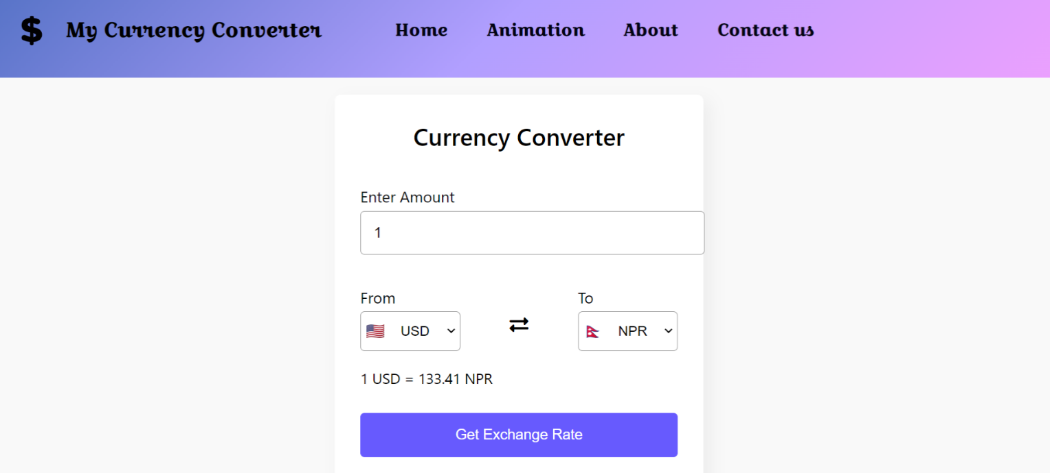

Welcome to our Currency Converter, your one-stop solution for hassle-free and accurate currency exchange. Whether you're a globe-trotting traveler, a shrewd investor, or a business conducting international transactions, our platform is designed with your needs in mind. Our user-friendly interface ensures that converting currencies is a seamless experience, even for those with minimal technical expertise. With real-time exchange rates and access to historical data, you can confidently plan your finances and make informed decisions. Access our tool on any device, anytime, and anywhere. Travelers can rely on our CURRENCY CONVERTER for precise rates, and your feedback matters to us as we continuously strive for improvement. We're committed to compliance and trust, following international financial regulations to provide you with peace of mind. Let our efficiency save you time and money. With a commitment to adapting to changing market conditions and serving as an educational resource on currency dynamics, our Currency Converter is here to empower you in the world of international finance. Welcome aboard!

* ANIMATION PAGE SCREENSHOT



We have added an animation page into our website to make it more dynamic and creative with the touch of animations. This animation page includes various currency rotating around a single point. It also had a attractive background which makes it more creative.

* ABOUT US PAGE SCREENSHOT



This is the About Us page which describes our organization and team members who have worked in this project.

* CONTACT PAGE OR FEEDBACK PAGE SCREENSHOT

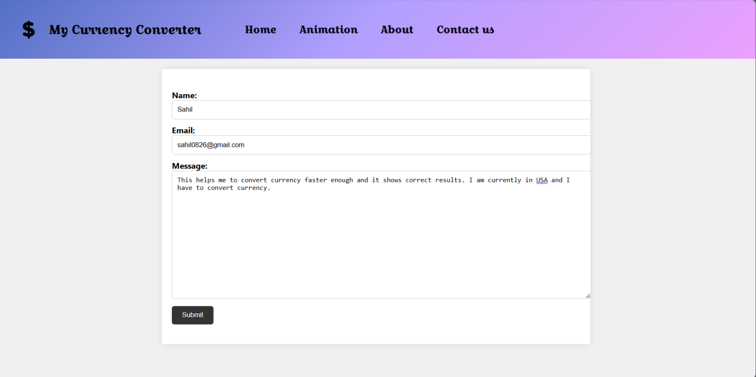

Welcome to our Contact or Feedback page, where your thoughts and opinions matter. We understand the importance of your feedback in making our currency converter platform even better. Whether you have questions, suggestions, or concerns, our dedicated support team is here to assist you around the clock. Our user-friendly feedback form ensures that reaching out to us is quick and easy, and rest assured, your privacy is of utmost importance to us. We aim to provide prompt responses to your messages and address your queries thoroughly. Your feedback is a vital tool in our ongoing efforts to enhance our services and tailor them to your specific needs. You can find our contact details below, including email and phone support, ensuring multiple avenues for you to connect with us. We appreciate your trust in our platform and look forward to serving you better. Thank you for choosing us as your currency conversion partner.

**CONCLUSION**

In conclusion, our currency converter project has embarked on a mission to provide a comprehensive and user-centric solution to the complex world of currency conversion. We have strived for accuracy, accessibility to ensure that users, whether they are individual travellers, investors, or businesses, can navigate the intricacies of international finance with confidence. We have also taken great strides in enhancing the user experience through multi-device compatibility and geolocation integration, making currency conversion seamless and efficient. The inclusion of animated data visualization on our Animation Page adds an engaging dimension to the otherwise complex world of currency dynamics. Our Contact or Feedback page serves as a direct channel for user input, a testament to our commitment to continuous improvement.

**LIST OF REFERENCES**

* <https://www.freepik.com/free-photos-vectors/gradient-background>
* <https://www.freepik.com/free-photos-vectors/dollar-logo>
* [https://fonts.google.com](https://fonts.google.com/)
* <https://developer.mozilla.org/en-US/docs/Web/CSS/color>
* [https://v6.exchangerate-api.com/v6/](https://v6.exchangerate-api.com/v6/)
* [https://flagpedia.net/india/download/api](https://v6.exchangerate-api.com/v6/)